King Saud Mosque in Jeddah

Spahic Omer

This is the biggest mosque in Jeddah. It is located in the city’s al-Sharafiyyah district, about 6 km north of historic Jeddah. It was completed in 1987. Its architect was ‘Abd al-Wahid al-Wakil. With the oil boom in 1973, Saudi Arabia provided a majority of commissions for ‘Abd al-Wahid. In collaboration with the Ministry of Pilgrimage and Endowment, a program for mosque architecture was established for the reconstitution of traditional architecture. A series of new mosques in a neo-traditionalist and revivalist style was also initiated. ‘Abd al-Wahid al-Wakil, as a leading authority in Islamic traditional revivalism, fitted the bill perfectly. As many as nine mosques in Jeddah were commissioned within the frame of the beautification and development of the city. They were built in the 1970s and 1980s. They varied in size: from tiny single-domed mosques, to the massive multi-domed and multi-vaulted ones.
Since this mosque is the largest in the city and is sited in the middle of modern neighbourhoods, it shows that neo-traditionalism in mosque architecture fares high on the architectural agenda of the Saudi authorities. This applies not only to the city of Jeddah, but also to the rest of the Saudi urban environments.
Like most of ‘Abd al-Wahid al-Wakil’s masterpieces, this mosque’s construction, too, is based on the utilization of load bearing walls, vaults and domes. It is built of “hollow baked bricks held together with mortar. Most of the brick surfaces are covered with white plaster, and in some cases, with granite. However, the interior of the vaults and domes are generally left exposed, and are only coated with a layer of brownish paint. As for reinforced concrete, its use is limited to specific elements, which include the foundations, lintels, and flat ceiling” (archnet.org/sites/579/publications/4069).
The mosque is “characterised by a complex plan which is aligned with the surrounding streets on three sides, but is also aligned with the qiblah direction on the fourth, or eastern side. The discrepancies between the street directions and that of the qiblah are compensated for by the addition of triangular shaped areas. These additions contain ablution facilities, classrooms, storage rooms, offices and residences. Those entering through the main entrance need to make a number of consciously arranged axial shifts before reaching the courtyard around which the prayer hall is arranged. The four iwan prayer hall covers an area of 5000 sq m and is symmetrically composed around an east-west axis. In addition to the four barrel-vaulted iwans, its main features consist of a large dome reaching a span of 20 m, two smaller symmetrically arranged 12 m domes, and a series of small 6 m domes covering the remaining bays of the prayer hall” (archnet.org/sites/579/publications/4069).
The mosque is further described as follows. “The mosque itself is rectangular, almost square, with a rectangular court built somewhat offset to the west. Four iwans open to the central court. The iwans are not emphasized as individual structures as in the Persian examples but are mere openings in a large screen wall. The north and south iwans are each set in front of a domed hall that separate four pillared halls to the east and west. The west halls are divided by two pillars each into three naves with to bays. The larger east halls have three naves with five bays and eight pillars each. The east iwan is the largest and connects the court to the largest domed hall that rises between the longer pillared halls in front of the qiblah wall. Irregularly shaped rooms fill the triangular spaces between the actual mosque and the outside facade on the north, south and east wall because the mosque is built at an angle to the street grid so that the qiblah wall may point to Makkah. The west facade opens to the Madinah Road with a large cubic structure added to the northern end. The minaret of the mosque towers over the south west corner of this structure that has a large iwan opening to the south leading into a domed hall that connects to a corridor that runs along the west wall of the mosque. This large iwan with the minaret on the left and the mosque connecting at a right angle to the right, both accessible by a flight of steps, form an iconic group that easily catches the eye when looking north along the Madinah road” (en.wikipedia.org/wiki/King_Saud_Mosque).
Neo-traditionalism between moderation and excess
Indeed, this mosque captivates, intrigues, astonishes and bemuses, all at once. In connection with it, ‘Abd al-Wahid al-Wakil was at his best, albeit not so authentic Islamic architecture. The mosque draws heavily, often directly, on a variety of historical prototypes and models belonging to the architectural heritage of the Muslim world. However, the culture of heavy borrowing and combining ideas and elements into mere quantities, have in this case been furthered in leaps and bounds. It became colossal. Consequently, rather than being a synergetic architectural whole, the mosque became just a sum of parts. It might still be regarded as a fairly comprehensive glossary of Islamic architectural heritage, many components of which are imbued with nothing but a symbolic, emblematic, inoperative and sentimental value.
As such, the mosque stands and operates alone. It is surrounded by modern neighbourhoods that architecturally radiate, by and large, the modernist and postmodernist spirits. The mosque is completely isolated and has nothing in common especially with its neighbouring institutional buildings. They all stand lonely and worlds apart. Architectural interaction and communication are non-existent. However, since the mosque is oriented essentially towards tradition and history, and its neighbourhoods towards the opposite direction, i.e., towards the future with its penchant for progress and modernity, the theoretical and practical gap between the two orbs is set to widen. The mosque may never make it to the upper echelon of modern-day architecture. It could be destined to remain no more than a part of tradition and history (past), despite its ostensible intent to look and move forward. The signs are already there, as the mosque is increasingly becoming the city’s leading “(neo)traditional” landmark and monumental icon. It is becoming a living museum of Islamic architecture, so to speak, ever more visited by the city’s travellers and tourists who come from near and far. It is becoming a memorial of, and to, the Islamic architectural heritage.
The mosque draws generally on the following styles and masterworks: Mosque-Madrasah of Sultan Hassan and other similar Mamluk masterpieces in Cairo; Safavid architecture in Iran with the Shah Mosque and Jameh Mosque in Isfahan leading the way; Seljuq architecture that most probably pioneered a four-iwan plan in mosque architecture, in particular, and in institutional architecture, in general; Ottoman architecture with special reference to the architecture of huge sabil-fountain buildings (even complexes) that dotted the urban centres of Ottoman Turkey, including Cairo (this mosque replicates one such sabil-fountain on its western side facing the main Madinah road); traditional Ottoman and Saudi architecture in Hijaz; and even traditional Indian (Mughal) architecture, because the top of the minaret features a chhatri (canopy or umbrella) and an onion dome.
All in all, tradition is to be resuscitated and kept if its worth and practicality are proven at the required theoretical, intellectual or applied levels; that is to say, if its being an advantage, rather than a disadvantage and liability, is ascertained. Tradition is to be enlivened only if it can add a distinctive and needed quality. Doing so can be done at two symbiotic levels: firstly, when integrating tradition’s diverse aspects into synergetic entireties; and secondly, when fusing those entireties with the modern responses to the vicissitudes of modern living. In this manner, tradition is to be seen as a goldmine to be tapped into by means and ways hitherto unknown. In the mechanism of cultural and civilizational survival, it is the principle of the survival of the finest and most beneficial that rules supreme.
Tradition should be seen as an antecedent to the modern ways of doing things. Modernity, by the same token, should be seen as a sequel to tradition. They are equals in an existential value and consequence. Their relationship ought to be like the relationship between day and night, which is constantly unfolding with one always entering or passing into the other. Their merging is so subtle, yet so dynamic, that one can easily testify to the presence of both, but cannot establish where they individually begin and where they end, and what exactly separates and what unites them. In the end, one humbly accepts that they are but one entity (phenomenon), which has but one personality and soul whose different aspects manifest themselves differently under the sway of different circumstances.
In this regard, one wonders what is remarkable and appealing in building mosques - such as King Saud mosque – with many components that have clearly outlived their usefulness, and have become architectural anachronisms, on account of the dynamism as well as irrevocability of cultural and civilizational evolutions. As beautiful and sentimental-value-loaded as they may be, such components often materialize in contemporary contexts as awkward, bulky and unsuited. They appear as though bizarre and eccentric, projecting themselves more as awe-inspiring and romantic, than truly beautiful. They also tend to waste spaces, affect the functions of sites and buildings, curtail the spatial rationality and rhythm, incur huge building, repair and maintenance expenses, and interfere with, as well as break, the prayer lines (sufuf).
As such, those architectural factors may mislead and misinform concerning the actual meaning of Islamic architecture, art, aesthetics and civilization. It may yet give the wrong impression about Islam as a whole and Muslims. They may promote a tenuous and an unsubstantiated civilizational idealism and escapism, at the expense of its vitality and pragmatism.
It is perfectly sound to advocate the ideas of applying the principles of classicism, upholding sensitivity to the historic continuum, considering the impact to the built and natural environment, etc., but all that ought to be done in the spirit of moderation, balance, realism and expediency. Excessive idealism and perfectionism may eventually boomerang.
Consciously or otherwise, people want their buildings to be truly theirs, to belong not only to their history, but also to their present time, and to exude the ethos not only of yesteryears, but also of today. Simply put, people want their buildings to be reflective of who exactly they were, who exactly they are, and what exactly they want to be in the future. They want them to be their testament and bequest. People want to communicate with their buildings, and to be emotionally attached to them. They want to be on the same wavelength as them.
For example, in this mosque, there is a massive and extravagant, but completely malfunctioning and unusable, sabil-fountain with an inscription “drinking water”, while at the same time many “functioning” watercoolers are provided for the similar purpose; the mosque features a heavy mass, a huge covered courtyard, and a series of domes with numerous windows perforated in their drums, but at the same time it relies almost completely on artificial sources for cooling, ventilation and lighting; the minaret is a sight to behold, but no loudspeaker is attached to it, as they are all placed elsewhere along the building’s roof; the mosque’s iwans are virtually disconnected sections inside the prayer hall, one of them even functioning partly as a storage, whereas the iwans in Islamic architecture were mainly developed institutionally to serve a number of functions including prayer, teaching, reading, meditation, lodging, keeping books, and to perform certain charitable activities.
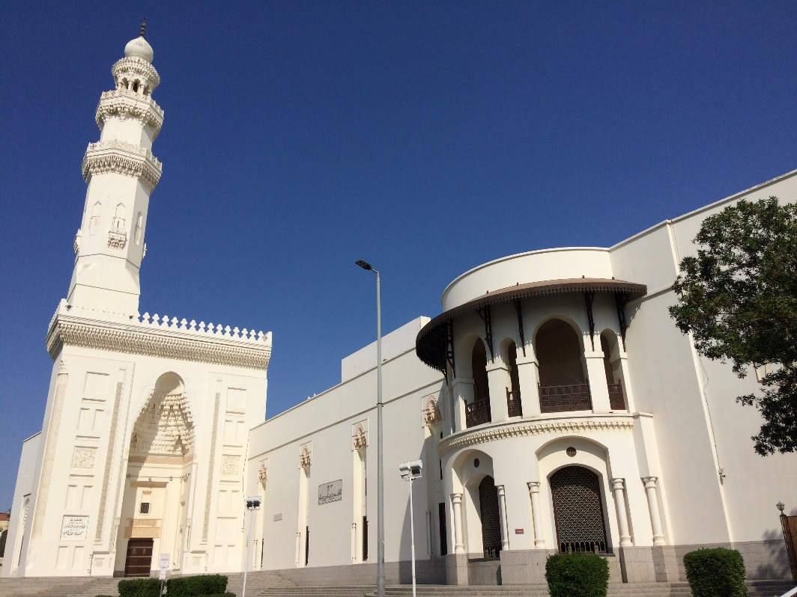
The mosque seen from the western side.

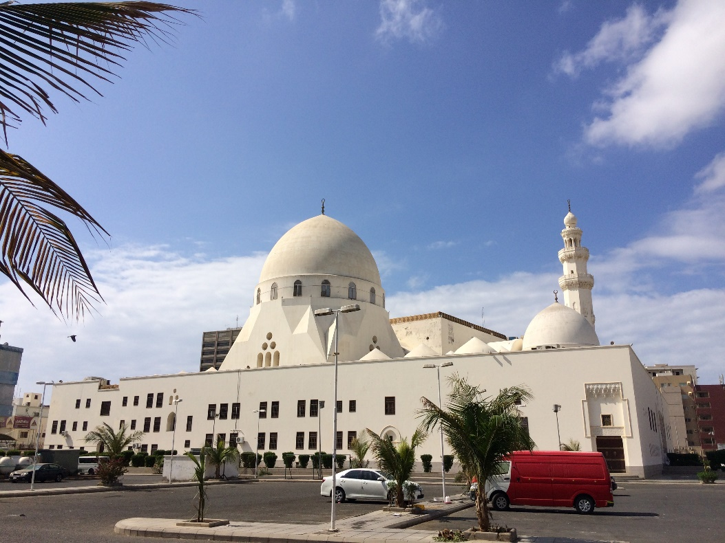
The mosque seen from the eastern (qiblah) side

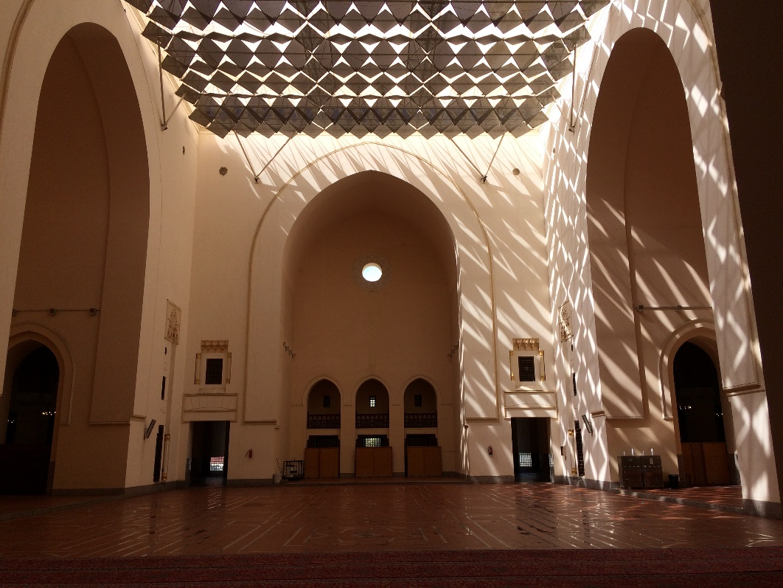
The covered courtyard with three iwans

